***Database Systems Lab 6 (Assignment)***

Name = Poorab Gangwani

Class = 4B1

Roll-Number= CS191092

1. Create a temporary table EmployeeInfo having three columns: Employee’s full name, Job title and Department. Show the structure of the table.

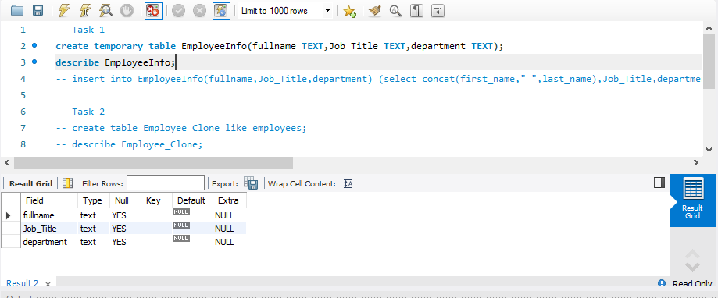

1. Clone the Employees table. Compare the structure of the cloned table to theoriginal table. Display all the data of the cloned table.

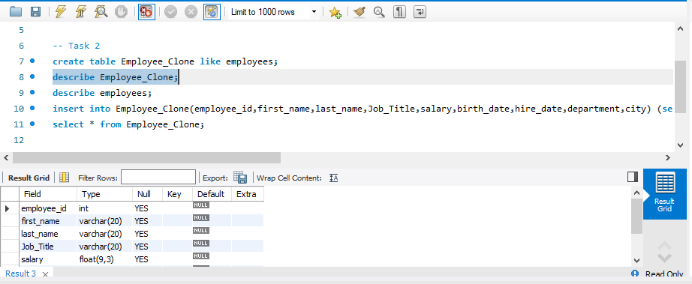

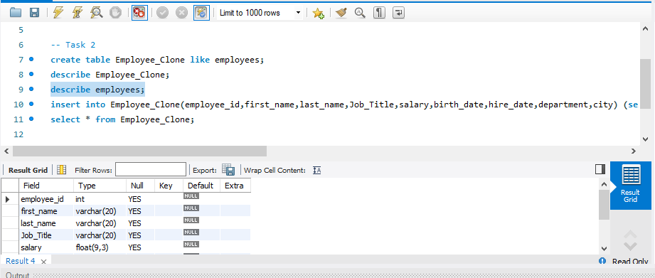

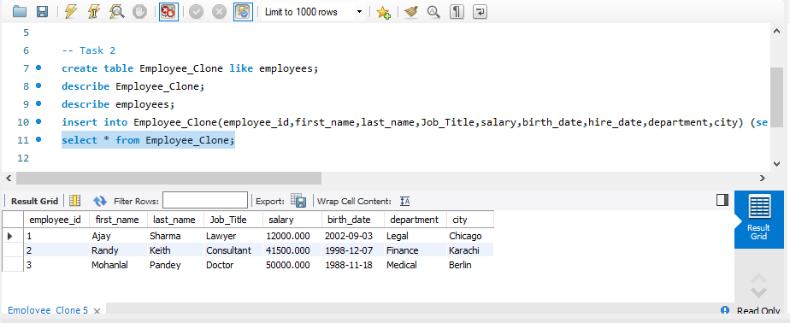

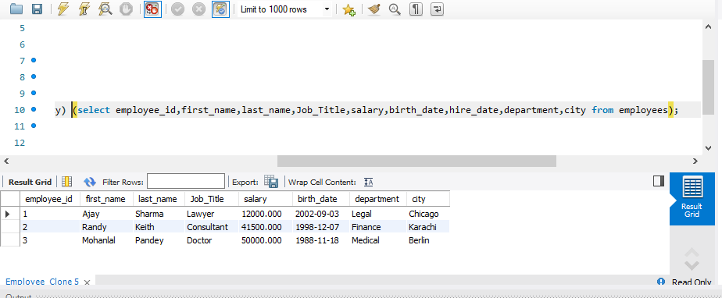

1. Drop the hiring date column from the cloned table and compare its structure with the original table.

